**Revision Questions Week 2 (STUDENT version)**

**\*\*This revision is intended to be carried out as a research and handwritten activity.\*\***

It will mainly use the following SQA resource although it is advised that you carry out extra research activities to reinforce your studies

[**http://softdev.hnd-computing.com/**](http://softdev.hnd-computing.com/)

Work your way through the online learning site and answer the questions as you go

**Understanding Variables**

Match the description of the data with the variable type

|  |  |  |
| --- | --- | --- |
| True or False |  | character |
| Number with decimal place | Integer |
| Multiple Characters | Float or real |
| Whole Number | String |
| Single Letter | Boolean (or logical) |

Q. What would happen if you tried to store the wrong type of data in a variable?

A

Q. Can variable names contain spaces Y/N

Q. Can you start a variable name with a number Y/N

Do the data types quiz and make a note of your score here ___________

Now complete the **Data Crossword**, make a note of any answers you struggled with

Work through the next few screens on arithmetic and when you reach the **Programming Constructs** page.

Identify which **Control Construct** each of the following statements describes

1. Two or more sets of alternative instructions with one path being chosen according to the value of a condition.

1. A list of instructions to be carried out one after the other in a strict sequence from top to bottom or from the beginning to the end. Each command will only be carried out once

1. A set of instructions that could be repeated zero or more times

What are, Sequence, Selection and iteration known as again?

Take some time to look through the samples on sequence, make note of the steps that are being followed in the design stages.

Do the **sequence quiz**, some questions relate to Java, so concentrate on the ones below.

Q’s **1, 2, 6, 7, 8, 9 and 10**

Don’t do the sequence challenges at this time, move on to the **Selection** section.

Make sure you are familiar with selection methods.

Now move on to the **Iteration** section

What are the two types of **While loop ___________ __________________**

If you know how many times a loop needs to be executed, what type of lop would you use ?

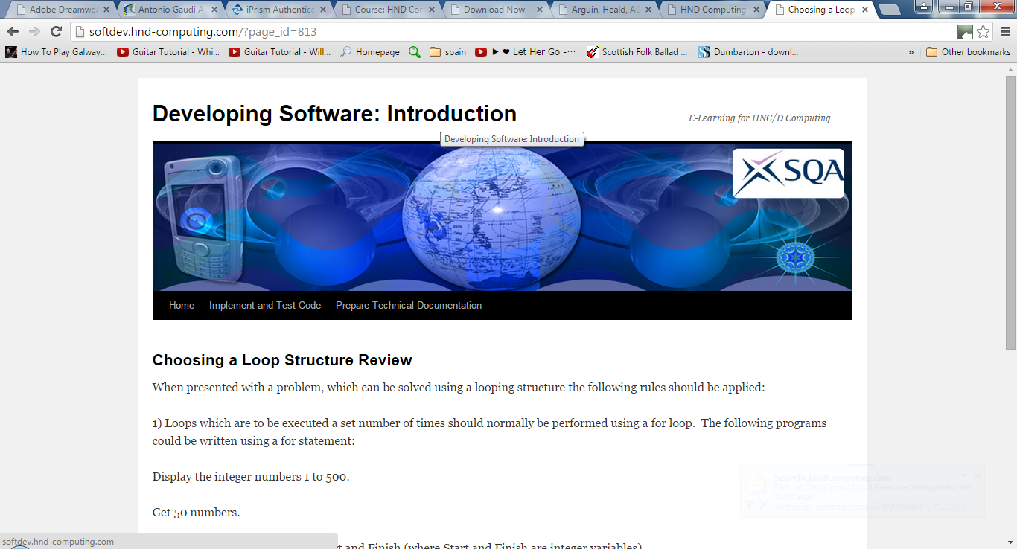Now go to the menu **implement and test code** and choose functions and parameter passing

Q. What is a function?

Q. What are the two types of functions found in programming languages

Go to <http://pages.cs.wisc.edu/~calvin/cs110/LOCAL_GLOBAL.html>

Q. What is meant by local variable, or local scope?

Now go to <http://www.pcmag.com/encyclopedia/term/43809/global-variable>

Q. What is a global variable?

Q. What is better practice, to use lots of global variable or keep them to a minimum and for what reason?

Q. What is better programming practice, to give variables and functions short meaningless names or to give them meaningful names that would make it easier for the programmer to follow?

Q. When writing a program, what would be the advantage(s) of commenting the code?

***---Now Jump to the following page on the SQA eLearning site---***

<http://softdev.hnd-computing.com/?page_id=308>

Q. What are the three basic categories of program errors

***When it comes to the theory of testing***

Q. What are two main approaches to testing?

***\*\*\*\*Over the next few weeks make sure that you are familiar with these two approaches\*\*\*\****

Q. What are the three main categories that test data can be divided into, and how would they be described?

***----Take some time to look at the examples of these types of test data----***

On the SQA eLearning site look for the section on **Code Maintainability**

Answer the following

Q. How would you describe a way of **defensive programming ?**

***Moving on***

Q. What does a Technical Guide consist of?

Take some time to become familiar what each of the 5 parts of the technical guide consists of

**Ask your lecturer to go over the answers to your revision and explain anything that you are unsure of**